**DATA SUMMARY:**

DETAILS OF TABLE CREATED WITH NO. OF ENTRIES FOR EACH TABLE.

|  |  |
| --- | --- |
| **TABLE NAME** | **N0. OF ENTRIES** |
| BOGIE | 170 |
| PASSENGERS | 20 |
| PASSENGER_BOOKING | 240 |
| ROUTE | 14 |
| STATION | 6 |
| TRAINS | 26 |
| TRAIN_OPERATIONAL_DAYS | 132 |
| TRAIN ARRIVES | 61 |
| TRAIN_DEPARTS | 61 |

**QUERY 1.**

**LIST OF STATIONS WITH NUMBER OF ROUTES OF DISTANCE MORE THAN 500 KMS.**THIS QUERY GIVES US THE COUNT OF ROUTES HAVING DISTANCE MORE THAN 500 KMS. FOR EACH STATION AND WHERE THERE IS MORE THAN ONE SUCH ROUTE EXISTS.

**SELECT** station_code, station_name, **COUNT**(route_no) **AS** no_of_routes   
**FROM** s20_1_station s, s20_1_route r   
**WHERE** (s.station_code = r.source_station_code **OR** s.station_code= r.dest_station_code) **AND** distance >500   
**GROUP BY** station_code,station_name   
**HAVING** **COUNT** (r.route_no) **>** 1   
**ORDER** **BY** **COUNT** (r.distance) desc;

**QUERY 1 OUTPUT :**

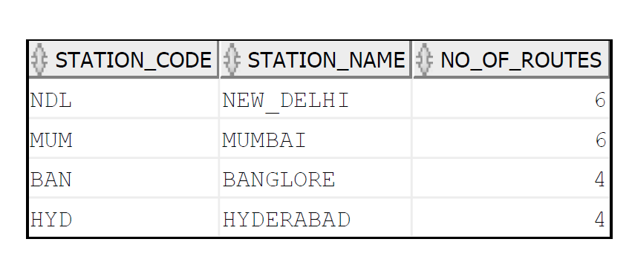

**QUERY 2.**

**DATA OF NO. OF PASSENGERS TRAVELLED IN EACH CLASS ON A PARTICULAR ROUTE. (WITH CUBE)**  
THIS QUERY GIVES US COUNT OF PASSENGERS TRAVELLED IN EACH CLASS FOR A PARTICULAR ROUTE. IT ALSO GIVES US OVERALL COUNT OF PASSENGERS TRAVELLED IN EACH CLASS WITH TOTAL NO. OF PASSENGERS IN OUR DATA. WITH THIS DATA WE CAN COME TO KNOW ABOUT THE MOST PREFERRED CLASS OF PASSENGERS.

**SELECT** t.route_no,class, **COUNT**(p.passenger_id)  
**FROM** s20_1_passenger_booking p, s20_1_train t  
**WHERE** p.train_no = t.train_no  
**GROUP** **BY** **CUBE** (t.route_no, class)  
**ORDER** **BY** t.route_no;

**QUERY 2 OUTPUT :**

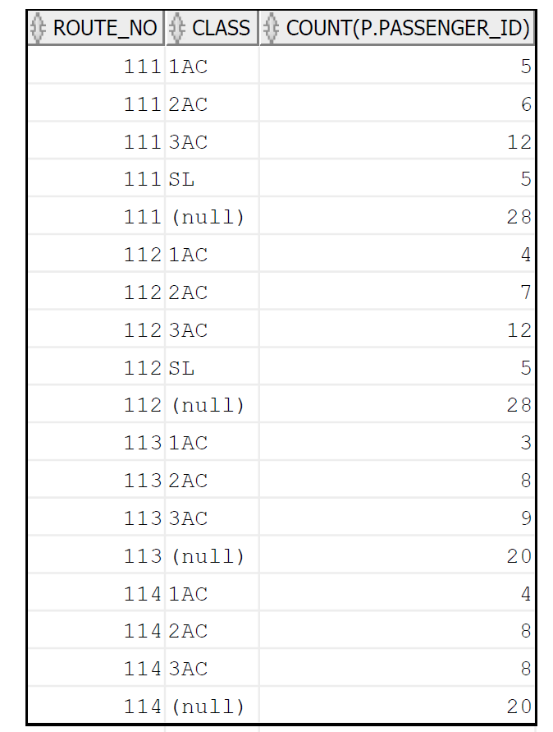

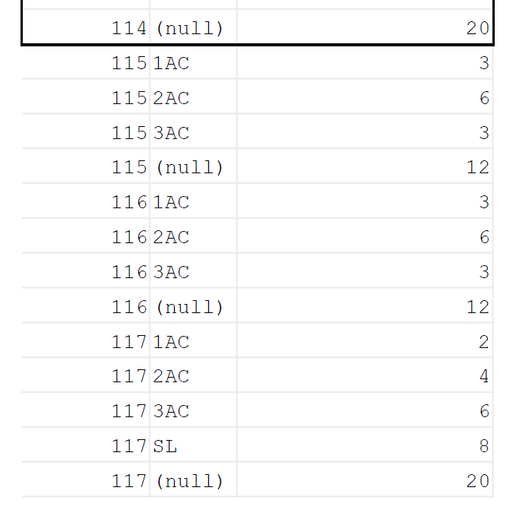

**QUERY 3.**

**DATA OF OVERALL PASSENGER TRAFFIC HANDLED BY A PARTICULAR STATION. (WITH ROLLUP)**THIS QUERY GIVES DETAILS OF TOTAL NO. OF PASSENGERS HANDLED BY EACH STATION WITH NO. OF PASSENGERS FOR EACH TRAIN AT THAT PARTICULAR STATION.  
THIS DATA CAN BE USEFUL FOR MAKING DECISION ON EXPANSION OF A STATION.

**SELECT** s.station_name, t.train_no, **COUNT** (p.passenger_id) **AS** passenger_count

**FROM** s20_1_passenger_booking p, s20_1_train t, s20_1_route r, s20_1_station s   
**WHERE** p.train_no = t.train_no and t.route_no = r.route_no **AND**

(r.source_station_code=s.station_code **or** r.dest_station_code=s.station_code)

**GROUP BY ROLLUP** (s.station_name,t.train_no)

**ORDER BY** s.station_name;

**QUERY 3 OUTPUT :**

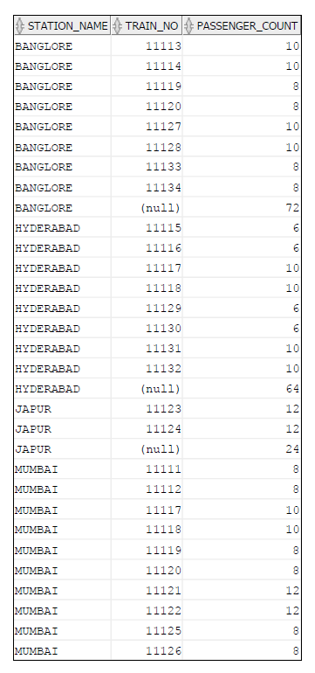

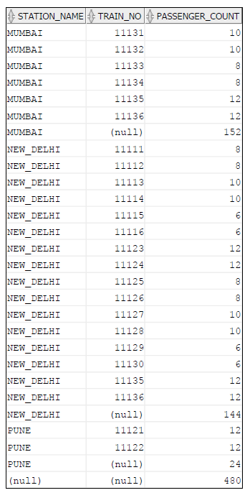

**QUERY 4**.

**LIST OF OUT OF LIFE (MORE THAN 10 YRS. OF AGE) BOGIES FOR EACH CLASS WITH OWNER STATION.**

**SELECT** s.station_name, b.class, **COUNT** (b.Bogie_No)

**FROM** s20_1_station s, s20_1_bogie b

**WHERE** (b.manufactured_year < 2010) AND (b.station_code = s.station_code)

**GROUP BY** s.station_name, b.class

**ORDER BY** s.station_name,b.class;

**QUERY 4 OUTPUT :**

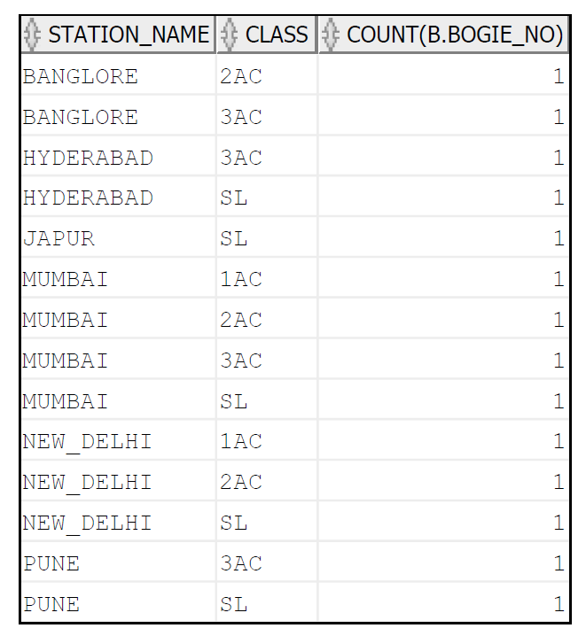

**UPDATE_QUERY:**

IN THIS QUERY WE ARE UPDATING NAMES OF HOLIDAY TRAINS IN TRAIN_TABLE.

**UPDATE** s20_1_train

**SET** train_name = 'PUNE-MUMBAI-HOLIDAY-SPECIAL'

**WHERE** train_no = 11121;

**UPDATE** s20_1_train

**SET** train_name = 'MUMBAI-PUNE-HOLIDAY-SPECIAL'

**WHERE** train_no = 11122;

**UPDATE** s20_1_train

**SET** train_name = 'DELHI-JAIPUR-HOLIDAY-SPECIAL'

**WHERE** train_no = 11123;

**UPDATE** s20_1_train

**SET** train_name = 'JAIPUR-DELHI-HOLIDAY-SPECIAL'

**WHERE** train_no = 11124;

**UPDATE_QUERY _OUTPUT :**

HERE IS THE EARLIER ENTRIES IN TRAIN_TABLE

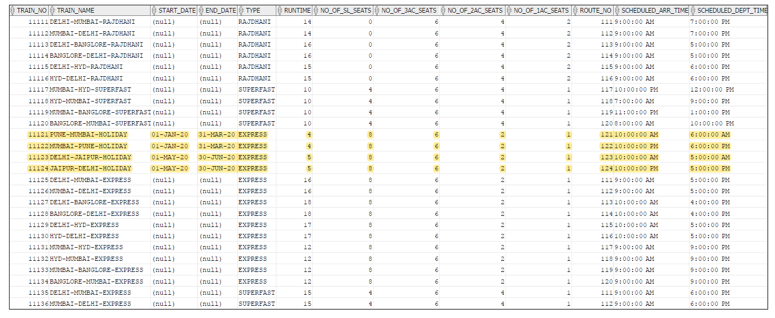

HERE IS THE UPDATED ENTRIES IN TRAIN_TABLE

